**DAILY ONLINE ACTIVITIES SUMMARY**

|  |  |  |  |  |  |  |  |  |
| --- | --- | --- | --- | --- | --- | --- | --- | --- |
| **Date:** | **08/06/2020** | | | | | **Name:** | **ASHISH GRACION MENEZES** | |
| **Sem & Sec** | **4&A** | | | | | **USN:** | **4AL18CS012** | |
| **Online Test Summary** | | | | | | | | |
| **Subject** | | **COMPLEX ANALYSIS,PROBABILITY AND STATISTICAL METHODS** | | | | | | |
| **Max. Marks** | | **30** | | **Score** | | | **22** | |
| **Certification Course Summary** | | | | | | | | |
| **Course** | **ARTIFICIAL INTELLIGENCE IN PYTHON** | | | | | | | |
| **Certificate Provider** | | | **Great learning** | | **Duration** | | | **7 hours** |
| **Coding Challenges** | | | | | | | | |
| **Problem Statement1:Write a C program to generate all the Set Partitions of n Numbers Beginning from 1 and so on** | | | | | | | | |
| **Status:Executed** | | | | | | | | |
| **Uploaded the report in Github** | | | | | **YES** | | | |
| **If yes Repository name** | | | | | **https://github.com/ash7745/lockdown-coding** | | | |
| **Uploaded the report in slack** | | | | | **YES** | | | |

Online Test Details1:18MAT41 I.A. 4 was conducted on 08/06/2020.There were 15 questions (MCQ) each question carrying 2 marks. The duration of the test was 40 min . The portion for I.A. 4 was from 2nd module

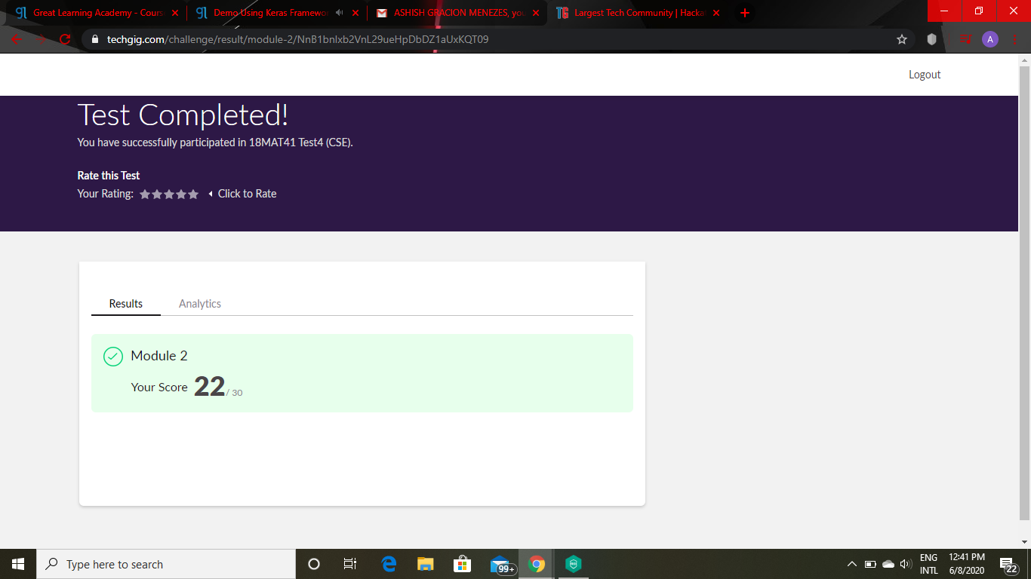

Certification Course Details:”ARTIFICIAL INTELLIGENCE IN PYTHON”(continuation)

Today I have 1 video which is of total duration 2.75 hours out of which I have completed 2 hours .In todays video I learnt about how artificial intelligence in python is used in KERAS FRAMEWORK

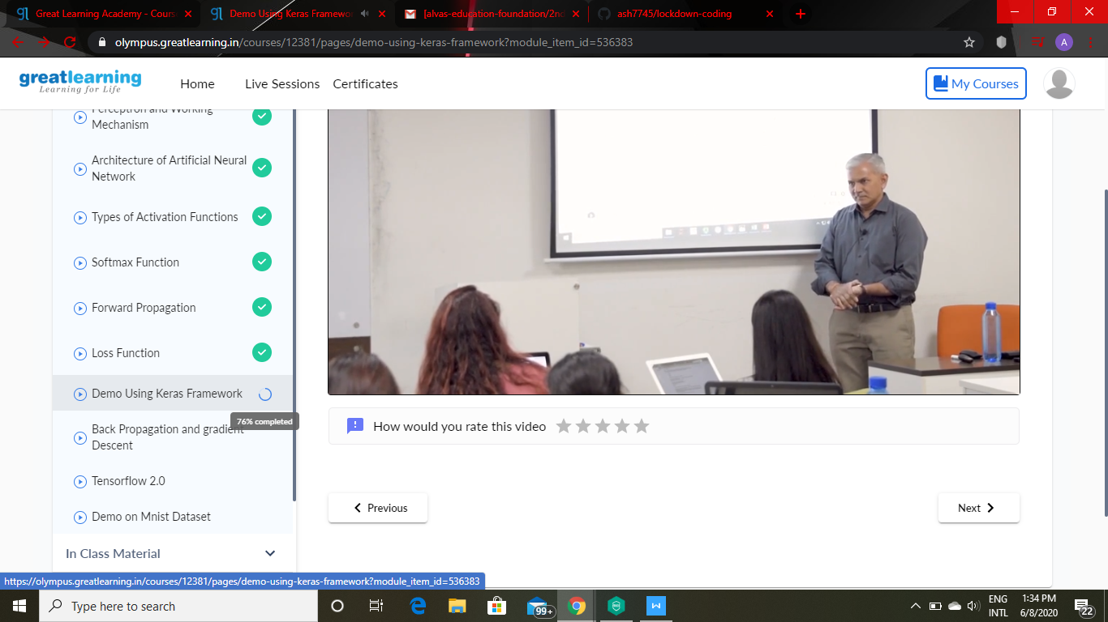

Coding details:**Write a C program to generate all the Set Partitions of n Numbers Beginning from 1 and so on**

